George-Valentin Boghez

Team members: George-Valentin Boghez

Similar products & Relevant Links(>=3)

**Name - Real-Time Piano Music Transcription Based on Computer Vision**

**Url -** [**https://www.cs.uleth.ca/~cheng/papers/tmm2015.pdf**](https://www.cs.uleth.ca/~cheng/papers/tmm2015.pdf)

**Relevant Features**

- audio Signal Processing (several disadvantages; it remains a research challenge)

- keyboard registration, illumination normalization

- pressed keys detection through hand detection mechanisms

- note transcription (MIDI)

**Name - PianoAssist**

**Url -** [**http://games.hs-kempten.de/entwicklung-einer-smartphone-basierten-augmented-reality-anwendung-zur-unterstuetzung-des-interaktiven-erlernens-von-klavierstuecken/**](http://games.hs-kempten.de/entwicklung-einer-smartphone-basierten-augmented-reality-anwendung-zur-unterstuetzung-des-interaktiven-erlernens-von-klavierstuecken/)

**Relevant Features**

- keyboard detection and AR extended keyboard visualization

- sound processing (the application waits for the user until the correct notes have been played)

- it’s using an android smartphone and was implemented with Unity and Vuforia

- real-time performance feedback

**Name - Detection and tracking of pianist hands and ﬁngers**

**Url -** [**https://www.researchgate.net/publication/4245767_Detection_and_tracking_of_pianist_hands_and_fingers**](https://www.researchgate.net/publication/4245767_Detection_and_tracking_of_pianist_hands_and_fingers)

**Relevant Features**

- hand detection and tracking

- keyboard image detection and rectiﬁcation

- ﬁnger recognition

**Name - Paper Piano using Python and OpenCV**

**Url -** [**https://rdmilligan.wordpress.com/2015/10/22/paper-piano-using-python-and-opencv/**](https://rdmilligan.wordpress.com/2015/10/22/paper-piano-using-python-and-opencv/)

**Relevant Features**

- printed piano detection

- OpenCV motion detection to work out which cell my finger is pressing

**Name - ARPiano - Efficient Music Learning with AR**

**Url -** [**https://link.springer.com/chapter/10.1007%2F978-3-319-99737-7_1**](https://link.springer.com/chapter/10.1007%2F978-3-319-99737-7_1) **(https://fernandotrujano.com/)**

**Relevant Features**

- framework for extending a physical piano using augmented reality

- keyboard and individual key detection

- key labeling, note visualizations, chord detection/suggestions and an intuitive, guitar-hero style tutorial mode to learn any MIDI song

- Used technologies & programming languages: augmented reality, Hololens, Unity, C#

-------------------------------------------------------------------------------------

Main Features

* Physical piano and printed piano keyboard detection
* Hand recognition and motion tracking (only when hovered over the keyboard) for pressed key detection or sound/signal processing (or all of the above... it needs further research on which one performs better)
* Library with default processed songs (or a method to transcript the music based on a user given file)
* Extension of the keyboard for guiding the user regarding the upcoming notes to be played
* Performance feedback system

Script / User Journey

* Optional - user authentication for storing progress, materials (songs), relevant data
* Choosing the prefered method of learning (w/ or w/out a piano)
* Picking the song from the default library (or uploading/importing one)
* Following the guidance while learning the movements
* Analyzing the app generated feedback
* Outperforming the previous performance

Moodboard

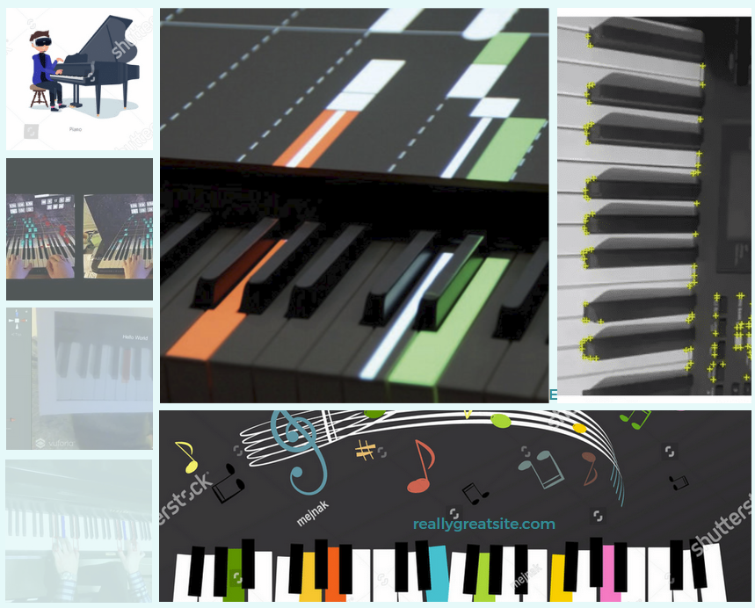

-------------------------------------------------------------------------------------

Technical Components

Technologies, Libraries, Assets (>=5)

Android, OpenCV, Unity, CNN, Vuforia, TarsosDSP